**Working of resistor’s and diode’s on breadboard**

21/1/2016, Computer Engineering Lab

The following report covers: An analysis of circuits, Using breadboard, LED (Light emitting diode), connecting resistors in parallel and series, voltage divider, resistor color codes and Kirchhoff’s law.

**Breadboard:**

It is a small tool to build circuits without having the need of connecting wires or soldering. It is tabular, on the sides it consists of holes to be connected to the positive and ground terminal. The part in red would be for the positive terminal and the part in blue/black would be the ground. Space marked from A to J signifies the area we can use in the breadboard to form circuits. In this area the rows are all connected on the inside and columns are separate. The schema of a breadboard can be seen from the image below.

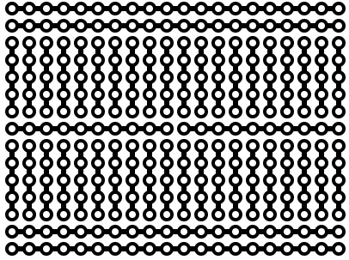

*(Image taken from:* [*https://en.wikipedia.org/wiki/Breadboard*](https://en.wikipedia.org/wiki/Breadboard)*)*

There are also buses at top, which can be used to complete the circuit. Note: A big breadboard may just be a collection of many more breadboards, which can be evident from more than one A to J marked at the top. It is necessary to make sure the two breadboards are connected accordingly in order for the whole circuit to work.

**Resistors and their color codes:**

There can be various measure of resistances offered by the resistors. Usually there would be a marking on the resistors giving its value but in some cases if it has been erased, the measure of resistance it offers can be found using the resistor color-codes.

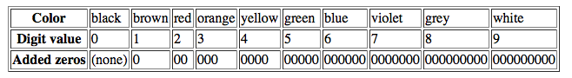*(Image taken from* [*http://computersystemsartists.net/spring16/csc7011/assign/lab1/lab1.htm*](http://computersystemsartists.net/spring16/csc7011/assign/lab1/lab1.htm)*)*

Gold and silver markings are used to show the tolerance and do not have a digit value. Gold has a tolerance of +-5% and silver has a tolerance of +-10%.

It is also a good practice to measure the value of resistance offered by the resistor using a multimeter. Though it will offer some variation in the reading, it should not affect the normal working of the resistor in a circuit. For example if by calculation a resistor of 500Ω is required a resistor of up to 460-540Ω should work just as well.

Measuring Resistance using a multimeter:

|  |  |
| --- | --- |
| Value of resistor by color code | Value of resistor by multimeter |
| 500**Ω** | 492.3**Ω** |
| 1000**Ω** | 979.6**Ω** |
| 100**Ω** | 94.1**Ω** |
| 500**Ω** | 491.7**Ω** |

The variation of resistance offered by the resistors is not significant and using them in a circuit for the values it was meant for should not cause any issues.

As to why these variations occur can only be guessed and might be because they are cheap and mass-produced in factories and little variations aren’t accounted for. Though in places where high-end resistors of specific values with little or no room for error are required, could be significantly higher in cost.

**Light emitting diodes:**

A led is a component, which turns a small current into visible light. It only conducts current in one direction like all diodes. An important factor when connecting LED to breadboards is one should be able to discern the positive side of the diode from the negative side. For this purpose most LED have a flat spot on the side of the lens just above the negative terminal. Sometimes this may not be the case. Therefore one would have to look at the two legs of the diode. The longer leg is the positive terminal. If both of these fail then trial and error on the breadboard could be used as a last option.

**Analysis of circuits using LED and resistors:**

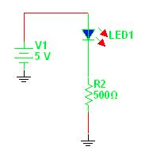

*(Image:* [*http://computersystemsartists.net/spring16/csc7011/assign/lab1/lab1.htm*](http://computersystemsartists.net/spring16/csc7011/assign/lab1/lab1.htm)*)*

In the circuit diagram the LED is connected to the positive terminal and the other end is connected to the resistor, this resistor ends the circuit by joining the ground terminal. The power supply is +5V.

**Using the 500Ω resistor** in the circuit we will have the voltage drop around the circuit as measured:

|  |  |
| --- | --- |
| Voltage drop at the LED: | 2.257V |
| Voltage drop at the resistor: | 2.747V |

The current entering any junction is equal to the current leaving that junction.

Actual current flowing through the resistor:

V= I X R

2.747 = I x 500

I= 0.0054A

**Using the 1000Ω resistor** onthe same circuit:

|  |  |
| --- | --- |
| Voltage drop at the LED: | 1.733V |
| Voltage drop at the resistor: | 3.248V |

Actual current flowing through the resistor:

V= I x R

3.248 = I x 1000

I = 0.0032A

Therefore the current flowing through the circuit is 0.005A when we use a 1000Ω resistor.

Therefore from the observations it is evident that as resistance increases the current in the circuit decreases.

If we were to **re-order** the given circuit it would give us something like the following diagram.

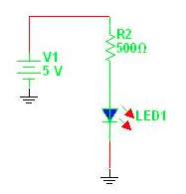

Note: Only the LED and the resistor have been switched.

The measurements are same, so re-ordering the circuit doesn’t affect anything.

|  |  |
| --- | --- |
| Voltage drop at LED: | 2.257V |
| Voltage drop at resistor: | 2.747V |

**Resistors in series and parallel:**

In the above experiment we used a single resistor and a LED. Now we try putting the resistors in series and parallel connection. On the breadboard, putting the second resistor just after the first resistor can form series connection. Similarly having the same row of the breadboard for initiating two resistors and ending the two resistors on another same row can form a connection in parallel.

The following diagram represents the resistors connected in **series**:

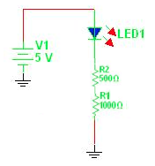

Here we have used two resistors of 500Ω and 1000Ω, the voltage drop along the different parts of the circuit measured were:

|  |  |
| --- | --- |
| Voltage drop at LED: | 1.706V |
| Voltage drop at 500Ω resistor: | 1.113V |
| Voltage drop at 1000Ω resistor: | 2.161V |

Current flowing through the circuit at 500Ω:

V = I x R

1.113= I x 500

I = 0.0022A

Current flowing through the circuit at 1000Ω:

V = I x R

2.161 = I X 1000

I = 0.0022A

Connecting these resistors in **parallel**:

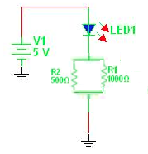

The voltage drop along the different parts of the circuit when resistors are in parallel will be:

|  |  |
| --- | --- |
| Voltage drop at LED: | 1.830V |
| Voltage drop at 500Ω resistor: | 3.152V |
| Voltage drop at 1000Ω resistor: | 3.152V |

Current flowing through the circuit at 500Ω:

V = I x R

3.152 = I x 500

I = 0.0063A

Current flowing through the circuit at 1000Ω:

V = I x R

3.152 = I x 1000

I = 0.00315A

Current flowing in circuit:

I = 0.0063 + 0.00315

I = 0.00945A

**Voltage divider:**

A voltage divider is a circuit, which has been connected in a way the resistors cause the voltage across the circuit to be divided into two halves.

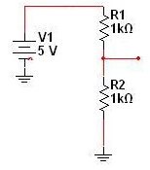

Here the two resistors cause the voltage across the resistors R1 and R2 to be divided into two equal halves.

Upon measuring the voltage drop across the two resistors via a multimeter.

|  |  |
| --- | --- |
| Voltage drop at R1 1000Ω: | 2.459V |
| Voltage drop at R2 1000Ω: | 2.498V |

As we can see the voltage is being divided into equal halves due to the resistors. If we were asked to divide the voltage in a way we would get **3.6V** at one of the test points we would need to change the resistors till we got the value via trial and error.

|  |  |  |
| --- | --- | --- |
| Resistance 1: | Resistance 2: | Voltage at Test point: |
| 500Ω | 500Ω | 2.467V |
| 500Ω | 1000Ω | 3.321V |
| 500Ω | 1488.2Ω | 3.741V |
| 500Ω | 1360.45Ω | 3.626V |

Note: Input voltage for all these experiments is 5V.

The second resistor is swapped to get an approximate voltage of 3.6V at the test point. Make sure to keep the same test point for all the different resistors used.

**Kirchhoff’s law:**

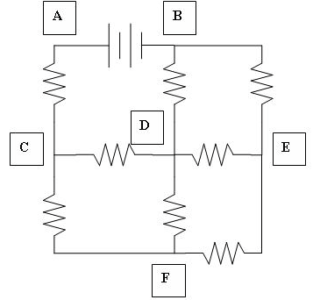

All resistors are 1kΩ and input voltage is 5V.

Voltage at A = 5.072V

Voltage at B = 0v

Voltage at C = 2.723V

Voltage at D = 1.448V

Voltage at E = 1.125V

Voltage at F = 1.556V

**Solving the circuit using Kirchhoff’s law:**

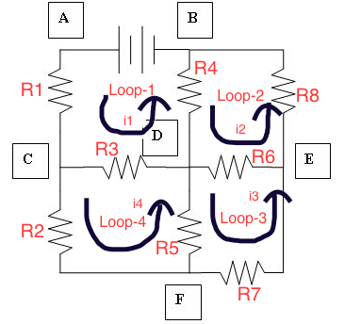

For Loop-1:

R1 x i1 + R3 (i1-i4)+ R4 (i1-i2) = 5

Since R1=R2=R3=R4=R5=R6=R7=R8 = 1000Ω

i1 + i1 – i4 +i1 –i2 = 5

3i1 –i4 -i2 = 5

For Loop-2:

R4 (i2 –i1) + R6(i2-i3) + R8 x i2 = 0

i2 – i1 + i2 – i3 + i2 = 0

3i2 –i1 –i3 = 0

For Loop-3:

R5 (i3-i4)+ R7 x i3 + R6 (i3-i2)=0

i3 - i4 + i3 + i3 – i2 = 0

3i3 –i4 –i2 = 0

For loop 4:

R1 x i4 + R3 (i4 – i1) + R5 (i4-i3)=0

i4 + i4 – i1 + i4 – i3 = 0

3i4 –i1 –i3 = 0

Solving the equation:

i1= 0.0023A

i2= 0.001A

i3= 0.00066a

i4= 0.001A

*Current flow in circuit:*

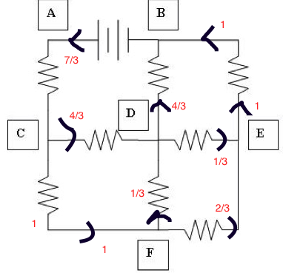

Vb – Va = -5

Vb = 0

Va= 5

Va – Vc = 7/3

Vc = 5-7/3= 2.6

Vc – Vd = 4/3

Vd = 2.66 – 4/3 = 1.33

Vc – Vf = 1

Vf = 2.66-1 = 1.66

Vd – Ve = 1/3

Ve= 1.33-1/3 = 1

Therefore

By Kirchhoff’s law:

Voltage at A: 5V

Voltage at B: 0V

Voltage at C: 2.66V

Voltage at D: 1.33V

Voltage at E: 1V

Voltage at F: 1.66V